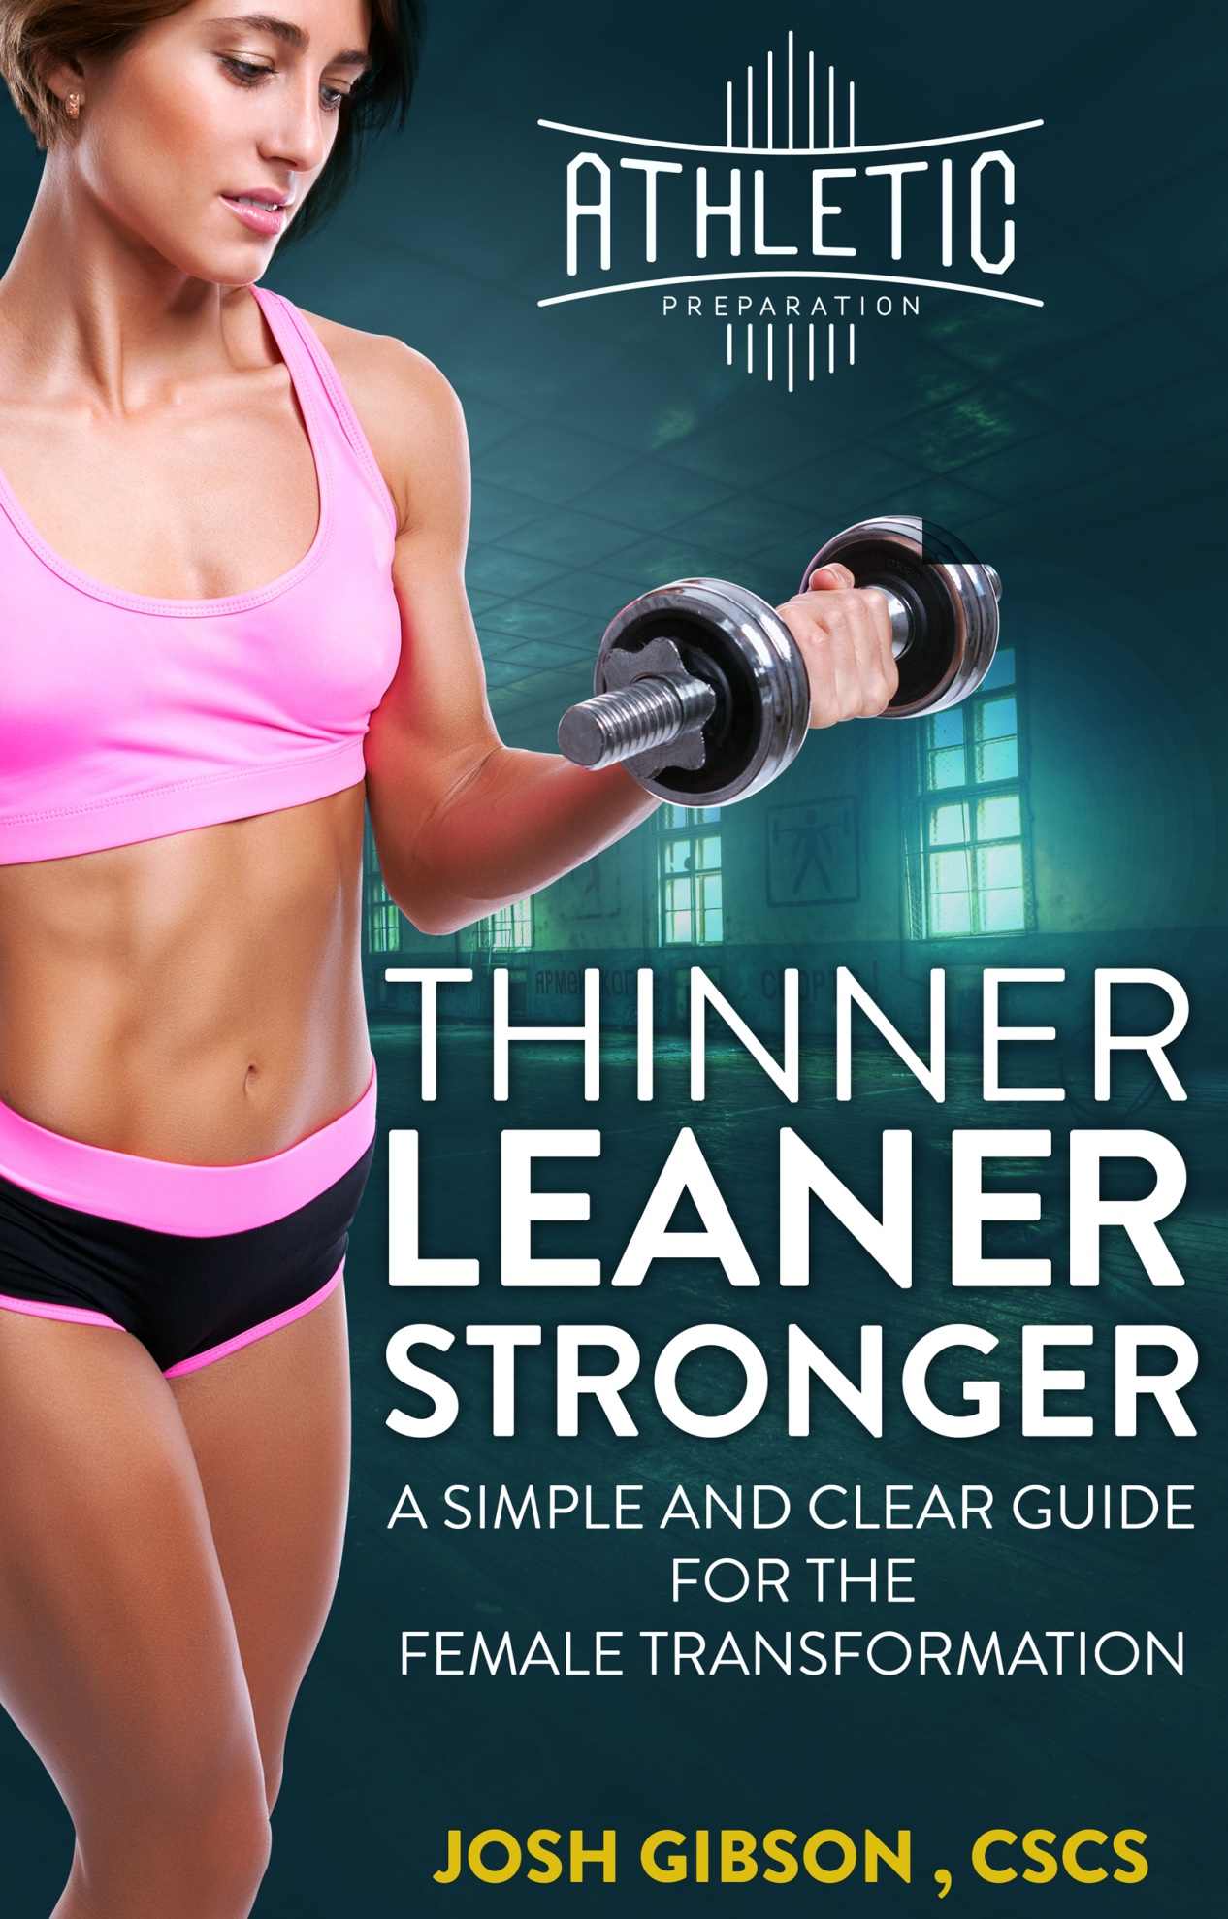
** 5 Rules for Fat Loss (Training + Nutrition) **
Fat loss does not have to be hard and it is not your fault.
Not having enough time is not an excuse, it’s a legitimate concern!
Sitting in traffic for 30+Minutes, taking the kids to practice, doing house hold chores, making dinner... There are simply not enough hours in the day.
On top of that…
There is so much information these days, you probably are overwhelmed and don’t know what to believe (and I don’t blame you).
We now understand that information is NOT the answer, and consuming too much information actually will bog us down, prevent us from taking action and just produce a spiteful cycle of anxiety like this:
Goal: I want to be healthy
Research: I read information to find perfect plan
Remorse: after 1 hour of reading / “googling” to your hearts content I feel exhausted and overwhelmed I will never achieve my goals
Recycle: I will muster up courage and go through the same cycle in another week…
The fact is yes, we complied some data, but never took any ACTION.
Action is your answer to your goals and what we will focus on moving forward.
Imperfect, Doing, Executing, Sticking to the plan ACTION.
We are going to mess up so get that through your head, you will mess up, you will fail…and it is OK!
After all, we can’t steer a parked car… so we will adjust (steer the car) as we take action (have our foot on the gas pedal).
We will now focus on 5 simple and effective HABITS (daily choices you must make) that will 100% get you to your goals without sucking all your time, money and energy.

- Don’t Eat As Much
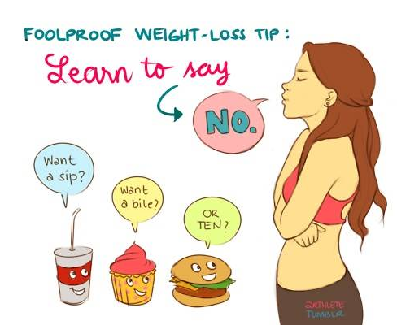
If what you have been doing is not moving you to your goals, then you are probably eating too much.
Your body is a machine and maintains a delicate energy balance on thousands of essential daily functions.
Example: (Bank Account)
For Weight Loss, you want it the opposite of the way you want your bank account.
In Simple Terms: MORE GOING OUT & LESS COMING IN.
How to Make This Happen:
Step 1: For the next 3 days, write down everything you eat and drink in a notebook. (This will give you a rough idea of how much you eat daily)
Step 2: All you have to do now is replace a few high-calorie foods (1 -2) with less calorie foods. Our goal we’ll be aiming for is a 300-500 calorie deficit / day.
Examples:
HIGH CALORIE FOODS | LOWER CALORIE FOODS
Fries / Potatoes / Fried Side Dishes | Salads / Veggies / Fruits
Bread | Lettuce Wrap

Yes. It is that simple. Don’t complicate it and start taking action.

2. Eat Healthy Foods
“Healthy Food” can be tricky and mean different things, to different people. I’m with ya, but there is a healthy food principle or universal truth and it goes like this:
More Nutrients with fewer calories
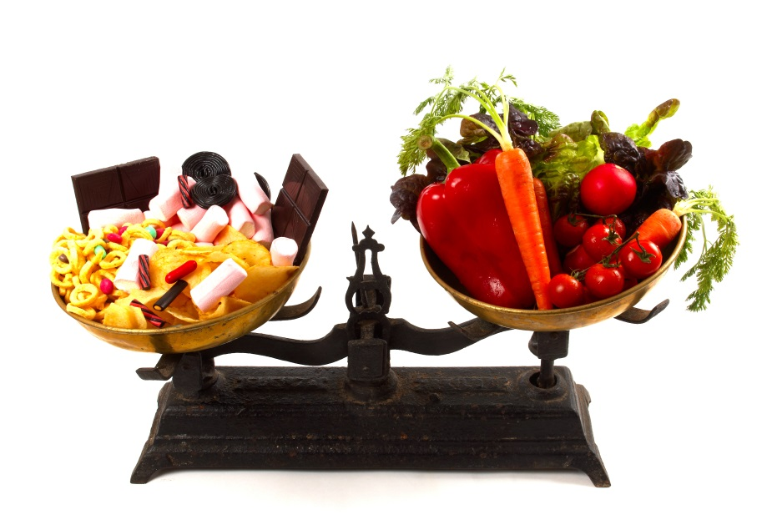
You can’t go wrong with: (more specific examples of each in pictures below)
-Lean Meats
-Vegetables
-High-Quality Fats
These are all relatively low in calories especially compared to anything that comes in a box, pre-packaged or processed.
#Winning
Awesome…But what does that look like?
Check out these epic graphics from Precision Nutrition!
(They have helped people lose over a total of 180,000 pounds of fat!)
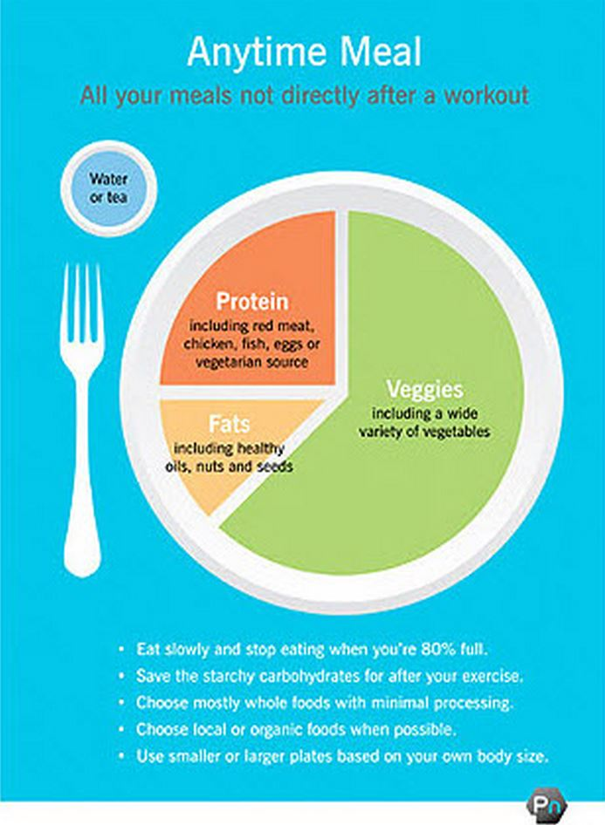
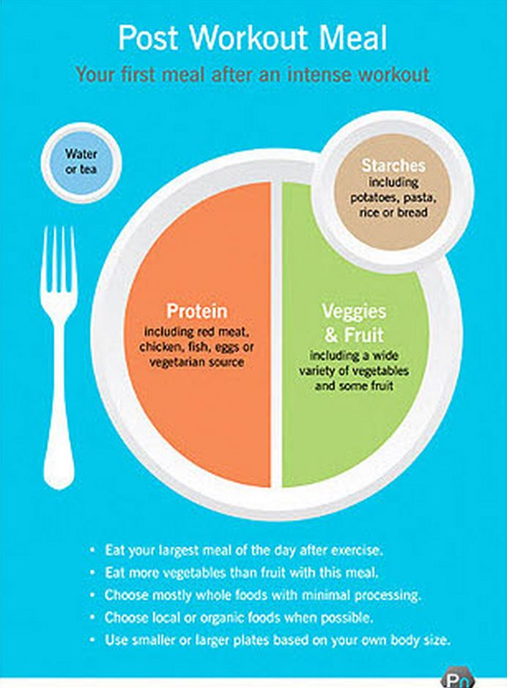
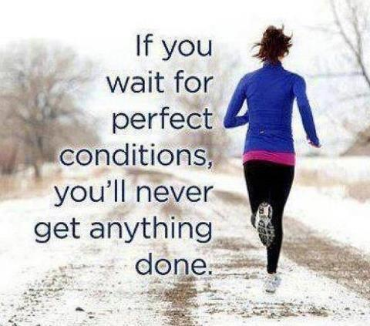
3. Move More Often
What should I do?
It doesn’t matter…Move!
More Action. Less Thinking. Remember?!
Movement = Calories being burned. Some things are better than others which we will cover but start simple with these options:
- Go for a walk / jog / bike ride in the morning
- Take the stairs at work
- Park far away at the grocery store
- Take a walk on your lunch break
Isaac Newton had it right; objects in motion tend to stay in motion unless acted upon by an outside force…or if they sit down on the couch…
By making this simple choice, it will start a domino effect of :
- moving more often / more frequently
- get your heart pumping which will release endorphins (hormones that make you feel good)
- boost your energy levels throughout the day
- relieve anxiety and clear your mental thoughts (helps focus)

4. Do Strength Training a few times a week
Want to accelerate your fat loss and get tone at the same time?
Start lifting weights…now! I’ll save you the googling time…
Resistance Training Will Not:
- Make you bulky / manly
- Grow a mustache
Resistance Training Will:
- Help you achieve a lean and tone body to be proud of
- Burn more calories everyday
- Prevent Osteoporosis (bone decay) and boost your confidence and self-image
Check Out Leanna Carr: (from her Instagram Account)
LEFT = Before Lifting Weights : RIGHT = After Lifting Weights
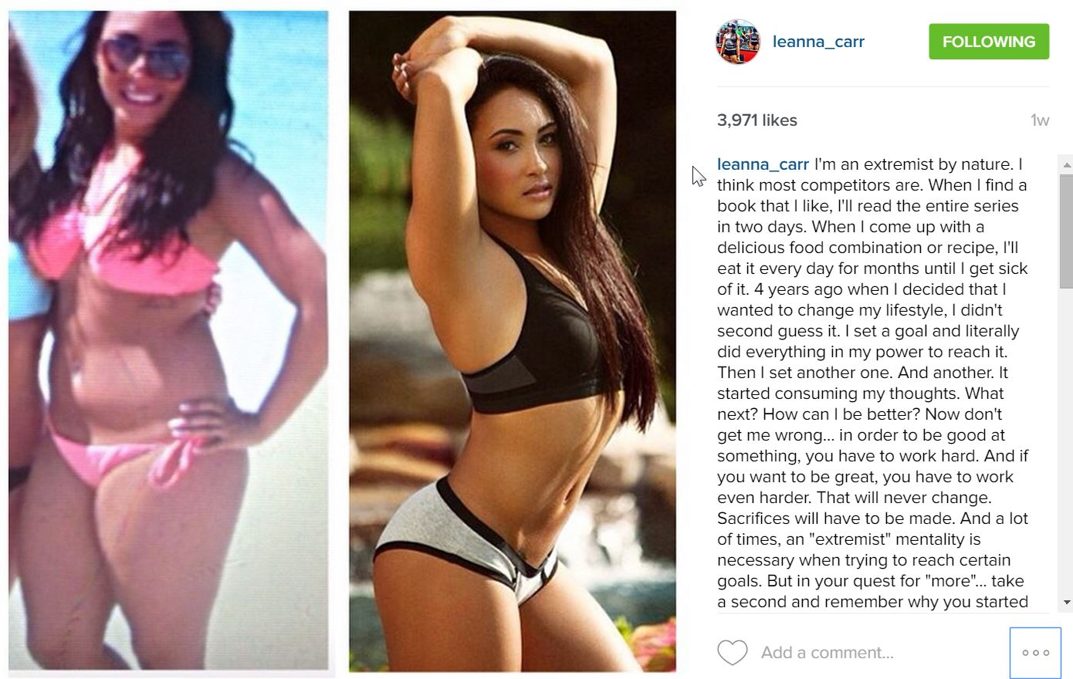
This is her Deadlifting 300 pounds too…
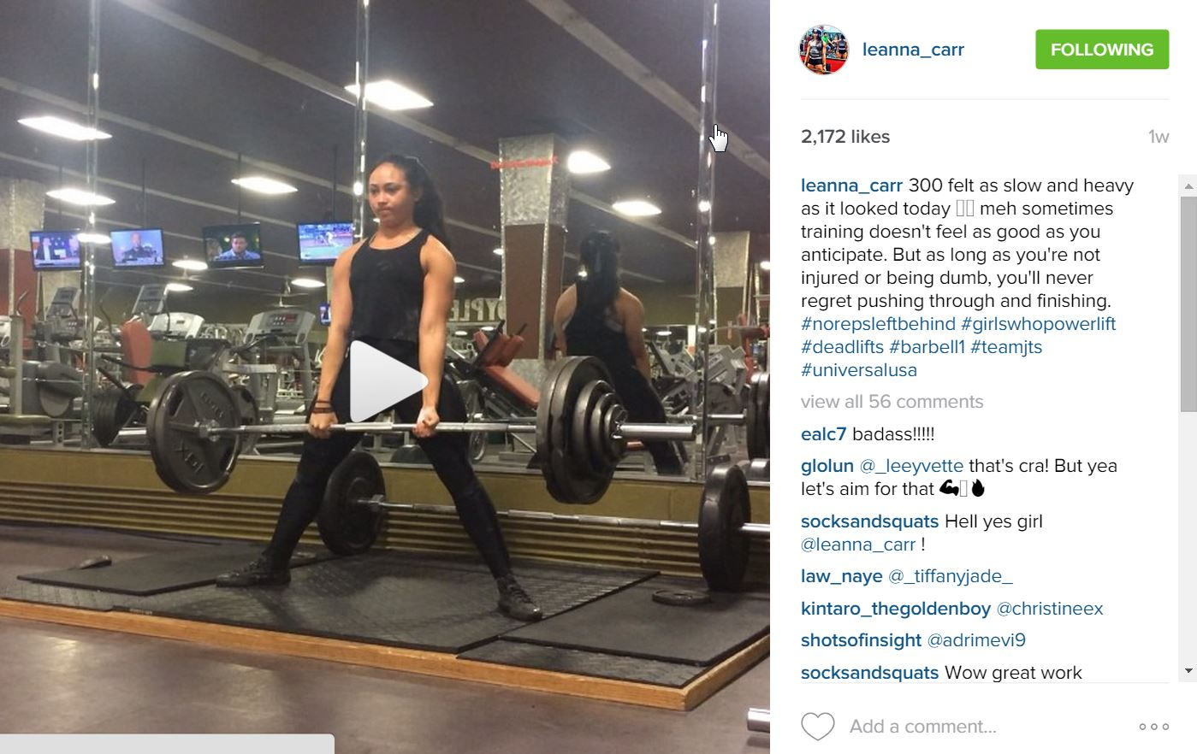
Does she look like a lady who is fit and tone without being too bulky?
Hire a Coach to teach you! Watch YouTube videos on “how-to” do the exercises safely.
A word of caution: Just start! You do not need a new or specific program, start with what you know, where you are at! Pick some exercises that are challenging yet doable and start making your goals come true!
Exercises Should:
- Involve more than 1 muscle at a time (Pull Up vs. Bicep Curl)
- Do Full Body Workout in less than 45 minutes (Upper and Lower)
- Make you grin on your face and challenge you to exert a lot of effort
- Keep rest under 45 seconds between exercises
- Start with higher reps (8-12 reps)

5. Replace Slow Cardio with High-Intensity Intervals
A lacking ingredient in 90% of people’s workout is: INTENSITY!
Crank it up a notch and get after it! Put your favorite playlist on, dig in and get to work girl!
When you work hard to pursue your goals, think about how much more you’ll appreciate your body knowing all the hard work, adversity you faced in the process and still knowing the fact you pushed through and would not be denied!
Strength training above will build your lean muscles.
High-Intensity will torch the additional calories.
High-Intensity Intervals Overview:
Doing short bursts (10-30 seconds) followed by light-moderate steady states (1-2 minutes).
High-Intensity Example: (you can use bike, treadmill, elliptical)
-30 second sprint (maximal effort – you should feel like stopping, but don’t!)
-60 second easy ride (keep moving, but should not feel winded)
Start with 5 total rounds of that and gradually add 1 round as the week’s progress.
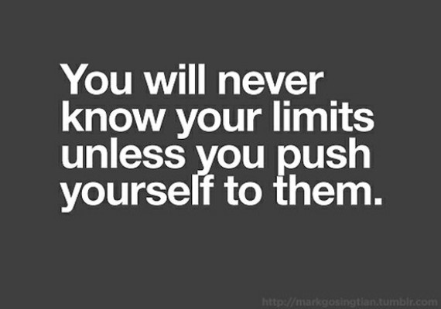

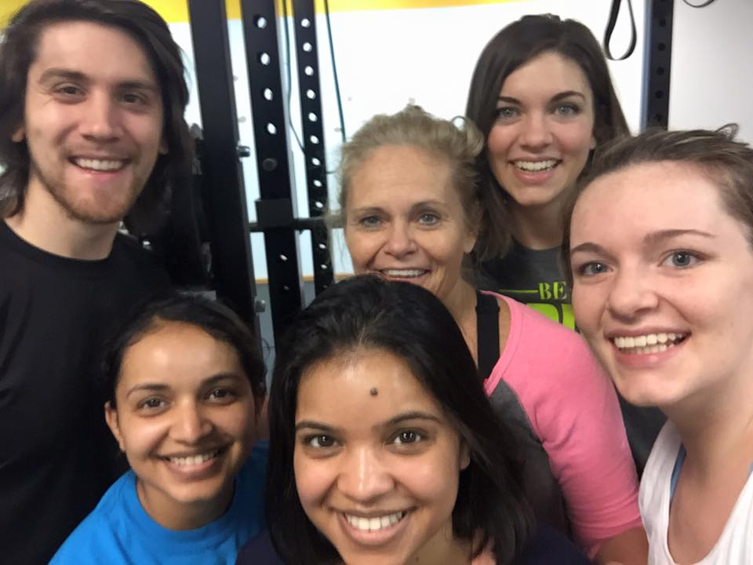
About The Author:
Hi! I’m Josh!
I created this manual with you in mind because many of the ladies we help get lean, burn fat and lose inches around their waist, arms and thighs come in feeling frustrated and overwhelemed with diet and training information.
I challenge you RIGHT NOW to take this seeming “too simple” of principles I outlined and put them into practice for 1 month. Heck, do just 1 of these things and do them very well for the month and you will change your body! I guarantee it!
You have the power to change right now, so you don’t need any further information, just ACTION!
And if you need any help… I’m here for you!
Josh@AthleticPreparation.com
248-872-0852 << My personal #

Here are some ladies that share the same struggles, fears and doubts but overcame them
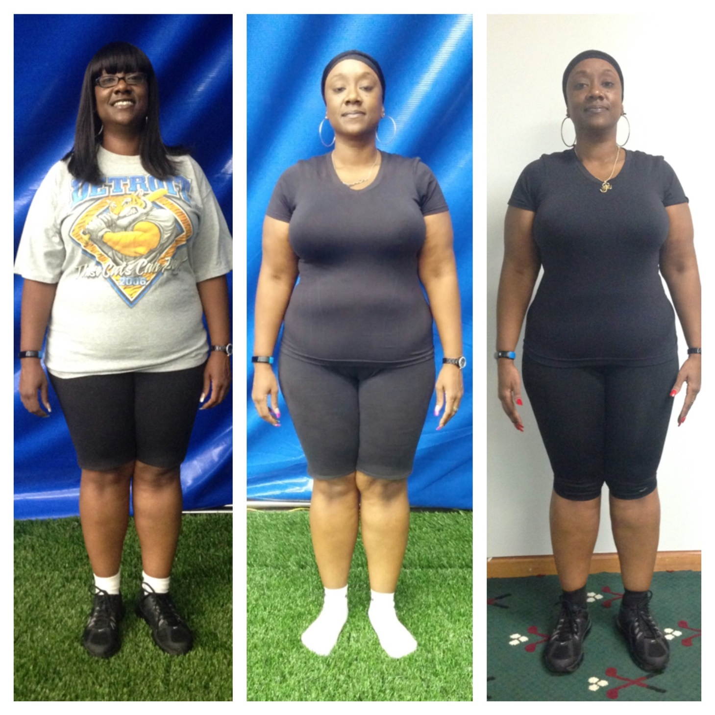
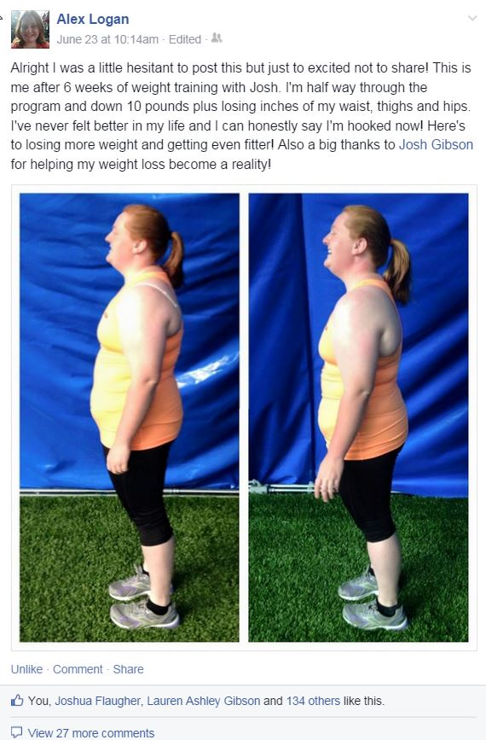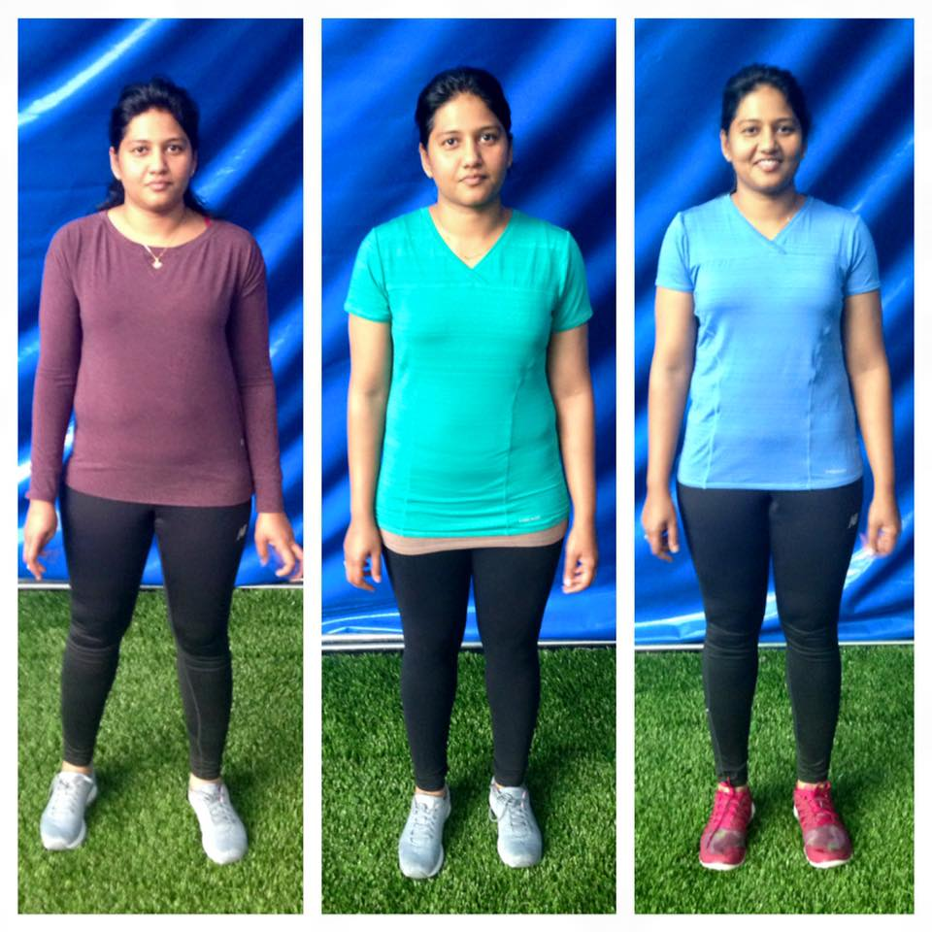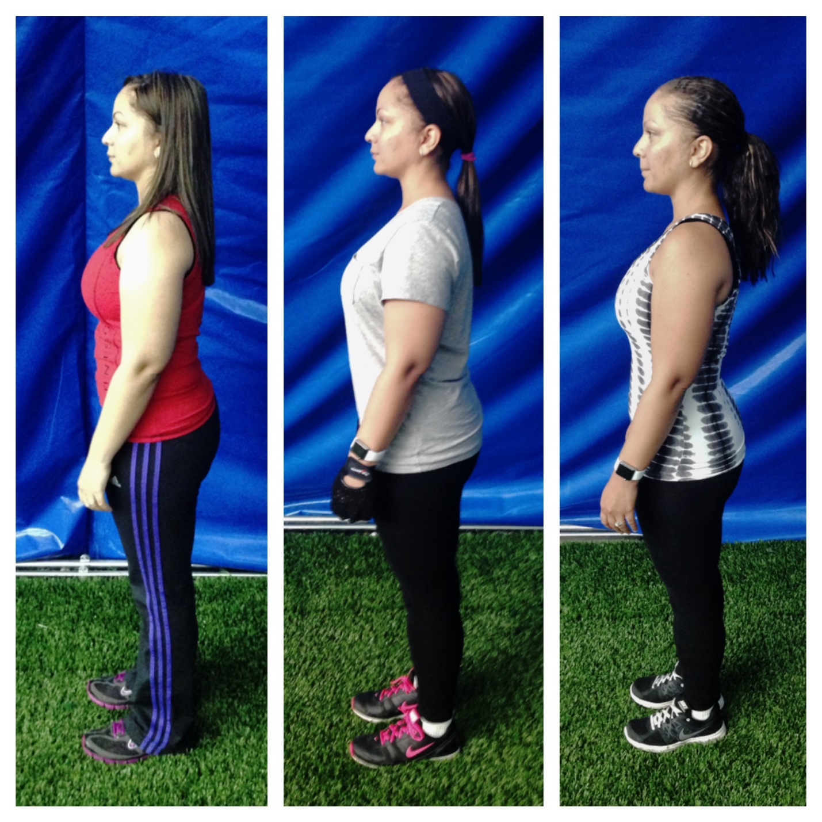

Many clients started getting healthier, and lean with us through are 7-Day Challenge Which You Can Apply For By Clicking The Photo!
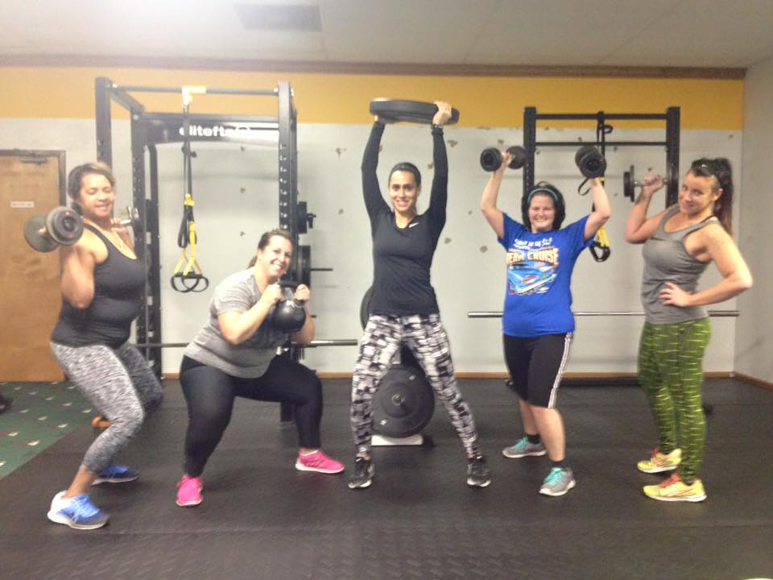

ACTION DEFEATS fear!

